Physical Science

**Learning intentions**

* Identify what forces are and what they can do
* Distinguish between contact and non-contact forces
* Explain how forces are measured

**Do now**

* Please write on board before students enter.
* 2 students hand out folders
* make a list of all the things your foot could make a soccer ball do.

**Concept development**

* A force is any **push** or **pull** that happens when two objects interact.
* There are many different types of forces. A simple push or pull is called an **applied force**
* **force** (*noun*) any push or pull that happens when two objects interact

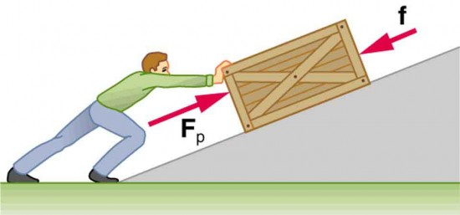

**Questions**

1. True or False: you must push something to create a force.

____________________________________________________________________________________________________________________________________________________________________

1. How many objects are needed for a force to exist?

____________________________________________________________________________________________________________________________________________________________________

1. Think, Pair, Share: which force is the applied force in this diagram? What is the other force?

____________________________________________________________________________________________________________________________________________________________________

**Contact and non-contact forces**

There are two main types of forces:

* **Contact forces** (the two objects need to be touching)
* **Non-contact forces** (the two objects do not need to be touching)

1. True or False: there can be a force between two objects that are not touching.

____________________________________________________________________________________________________________________________________________________________________

1. Is an applied force a contact or non-contact force? Why?

____________________________________________________________________________________________________________________________________________________________________

1. Think, Pair, Share: what is the force keeping you on the ground? What type of force is it?

____________________________________________________________________________________________________________________________________________________________________

**What can forces do?**

Forces can make objects:

* + Change **speed**
  + Change **direction**
  + Change **shape**
* The same force will sometimes make more than one of these changes happen.

**How are forces measured?**

* Forces are measured in **Newtons** (**N** for short, not n).
* You can measure applied forces with scales or a spring balance.

**Questions**

1. What three things can a force change about an object?

__________________________________________________________________________________

1. Think, Pair, Share: which of these three changes will happen to the ball?

__________________________________________________________________________________

1. Brody says that forces are measured in kilograms. Is he correct? Why or why not?

__________________________________________________________________________________

**When describing a force, you need to include:**

1. What is pushing / pulling what
2. Any changes to the objects’

* Speed
* Direction
* Shape

1. Describe the force at work in the pictures below.

|  |  |
| --- | --- |
|  | The ________ is pushing / pulling the ________. This is causing the ________ to change ________. |
| 1. http://lh3.ggpht.com/_VCVHceBcFjY/SaFYGwBOW2I/AAAAAAAAOXM/puU_eVS67vc/IMG_2733_thumb.jpg?imgmax=800 | The ________ is pushing / pulling the ________. This is causing the ________ to change ________. |
| 1. http://untitledskate.com/wp-content/uploads/2010/05/dave-pushing1.jpg |  |